Azure Biceps Understanding :

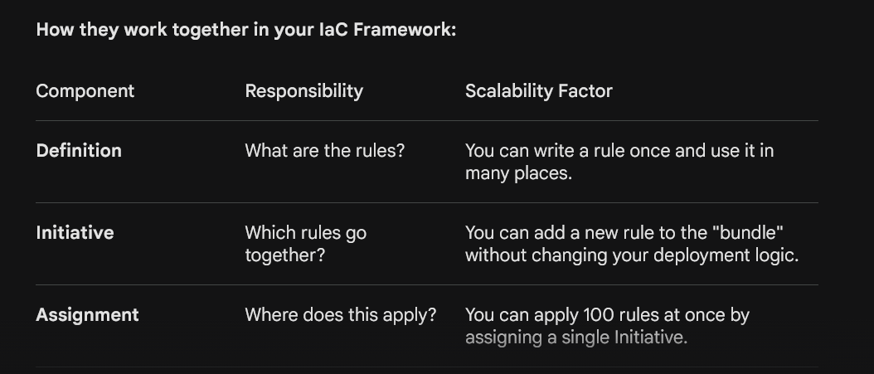

In short: You Define the rule, you Group them into an Initiative for easy management, and you Assign them to your subscription to start protecting your environment

1. Policy Definition (The "Law")
The Definition is where you write the actual logic. It defines exactly what is allowed or denied. It doesn't do anything on its own; it is simply a "rulebook" entry waiting to be used.
- Role: Defines the Logic.
- Analogy: A law that says, "All drivers must wear a seatbelt."
- Key Content: The if-then rules (e.g., If a resource is a Virtual Machine and then it must have encryption enabled).

2. Policy Initiative (The "Law Book")
An Initiative (also called a Policy Set) is a collection of several Policy Definitions grouped together. This is the "Scalability" engine of your framework. Instead of managing 50 individual laws, you group related laws into one "bundle."
- Role: Defines the Grouping.
- Analogy: The "Traffic Safety Act," which contains laws for seatbelts, speed limits, and traffic lights.
- Key Content: A list of multiple Policy Definitions and how they share parameters.

3. Policy Assignment (The "Police Officer")
The Assignment is the action. A law or a law book does nothing until it is enforced. When you "Assign" a Definition or an Initiative to a scope (like a Subscription), Azure begins to monitor and enforce those rules.
- Role: Defines the Enforcement.
- Analogy: Assigning a police officer to a specific highway to ensure everyone follows the "Traffic Safety Act."
- Key Content: The scope (where it applies), the enforcement mode (Deny or Audit), and the specific values (e.g., "Apply this to the Production Subscription").

